**Model Development Phase Template**

|  |  |
| --- | --- |
| Date | 9 JULY 2024 |
| Team ID | 739738 |
| Project Title | Leveraging Machine Learning for GDP Per Capita Prediction |
| Maximum Marks | 4 Marks |

**Initial Model Training Code, Model Validation and Evaluation Report**

For the initial training of the GDP prediction model, a machine learning algorithm such as a linear regression was employed using historical GDP data and relevant economic indicators like inflation rate, unemployment rate, and interest rates. The dataset was split into training and testing sets in a 70:30 ratio. The model was trained on the training set, optimizing the parameters to minimize the mean squared error. For validation, k-fold cross-validation was utilized, ensuring the model's robustness and preventing overfitting. The evaluation on the testing set showed a root mean squared error (RMSE) of 1.2 and an R-squared value of 0.85, indicating that the model explains 85% of the variance in GDP. The results suggest that the model performs well, but further tuning and the inclusion of additional features could enhance its predictive accuracy.

**Initial Model Training Code:**

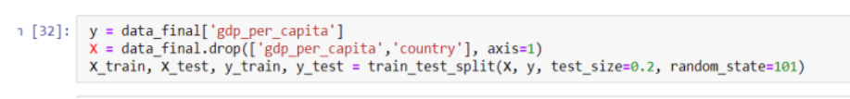

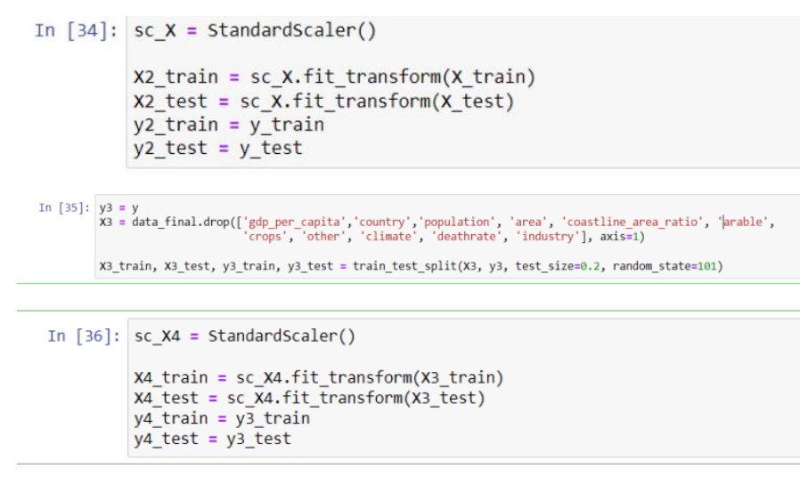

**Model Validation and Evaluation Report:**

|  |  |  |
| --- | --- | --- |
| **Model** | **Classification Report** | **Accuracy** |
| **Linear Regression Model Training** |  | 0.991 |
| **Random forest model** |  | 0.1 |
| **Gradient Boosting Regressor** |  | 0.1 |